Chaplin’s Tramp Striving for Heroic Significance

By Elijah Levy, Ph.D.

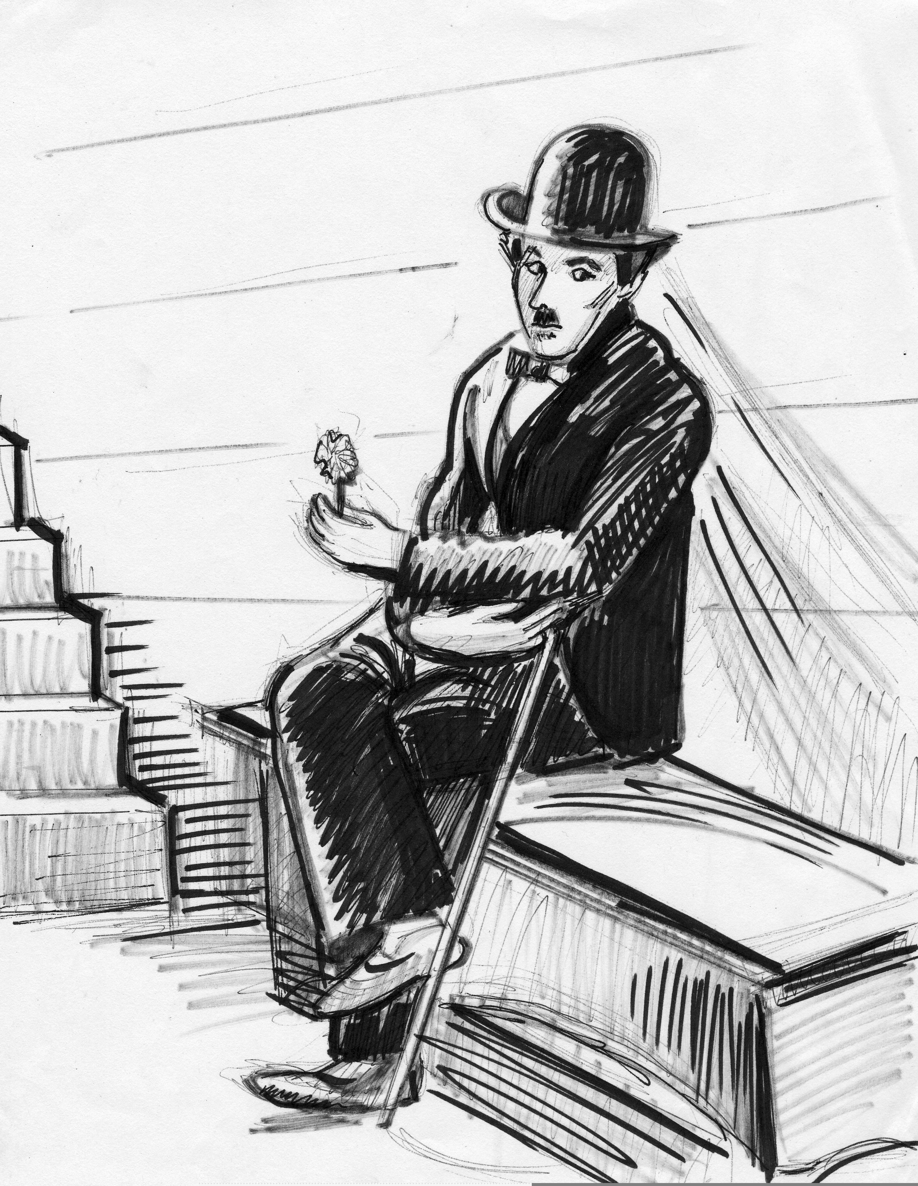

by Arlene Gardipee

In film history, an enduring image that embodies heroism in its truest spirit is Charlie Chaplin’s tramp. The tramp made more people laugh than any other character in film history in the early 1900’s and is considered one of the most universally recognized figures of all time. His character was the unassuming, altruistic, lonely, well meaning vagrant with oversized trousers, a tight fitting coat, large shoes, a bowler hat, moustache and a cane. Despite being a tramp, he insisted on being treated with dignity. Understandably, he was misunderstood by society, labeled, devalued and stigmatized as irrelevant. For some, the tramp represented freedom from the limits of a stratified society of individuals leading routinized lives —and he was socially marginalized for being unemployable, homeless and incapable.

The majority of Chaplin’s films were silent, requiring audiences to listen with their eyes. The tramp’s popularity was attributed to the universal understanding of pantomime. Since pantomime requires no spoken language-- communication through physical movement is easily understood. It is the universal language of life happening at the plane of movement. Movement can be trusted more often than words professing to action, and it reveals one’s intentions and motives. Thus, pantomime lent itself nicely as a method for the tramp to be trusted and reveal his altruism. The caring social gestures the tramp routinely expressed convinced audiences of the “little fellow’s” integrity. When the talkies emerged, Chaplin said “Talkies are spoiling the oldest art in the world—the art of pantomime. They are ruining the great beauty of silence. They are defeating the meaning of the screen.”

Charlie Chaplin was born on April 16, 1889 in London, England. At the age of five, Chaplin performed in a music hall. In 1896 his mother could not locate work and Chaplin and his half-brother Sydney were taken to a workhouse in Lambeth, London. He was the product of parents who were performers, his father a vocalist and actor and his mother an attractive actress and singer. A little later, he and his half-brother were relocated to Hanwell School for Orphans and Destitute Children. In 1900, at age 11 Chaplin’s brother Sydney managed to get Charlie a role as a comic in Cinderella which was playing at the London Hippodrome. Chaplin arrived in America in 1912 after being hired by the Karno troupe. Soon, Mack Sennett saw Chaplin’s acting and hired him to work in the Keystone Film Company. Chaplin was a big hit with American audiences and was offered a motion picture contract. At the tender age of 12 Chaplin’s father died an alcoholic. Hannah, his mother suffered from a mental illness and was institutionalized at the Cane Hill Asylum at Coulsdon.

By 1915 Chaplin’s tramp was widely recognized as the lonely, caring, homeless, and resilient character in search of adventure, romance and a purposeful life. Chaplin’s movies predictably contained a measure of sentimentality and pathos. The tramp was a lonely traveler on the unforgiving, merciless highway of life without funds, a regular meal or friends. These undeniable themes derive from his early childhood memories of being homeless as a child, neglected, and living in poverty. The creation of the tramp symbolized the “little fellow” with which Chaplin readily identified. He was acutely aware of the pain and suffering caused by the depression in America. It is for this reason his tramp is depicted experiencing discrimination, poverty and unemployment. In his feature films the tramp is likeable, unassuming, good hearted and lovable. Despite being a vagrant, he expects to be treated with dignity. In “The Kid” his first full length feature film in 1921, he is heroic—rescuing an orphaned child about to be taken to the orphanage, and attempting to be a loving, capable, surrogate father.

In “City Lights,” a romantic comedy, he hesitatingly falls in love with a blind woman and makes it his mission to care for her—pay her rent to avoid being evicted and pay for an operation to restore her sight. The story is simple, yet powerful and poignant in its portrayal of the effects of stigmatization. The blind woman, selling flowers on the street, mistakes the tramp for a wealthy man because of the mutual exploitation that occurs between the tramp and the wealthy man. The eccentric, wealthy and suicidal man engages the tramp for friendship only when he is intoxicated, and when sober he realizes what a grave mistake he has made befriending a vagabond and allowing him into his home. The tramp obtains money from the wealthy, intoxicated millionaire and offers it to the blind woman to pay her rent and for the operation to restore her vision.. The developing romance between the tramp and the blind woman is beautifully handled. For the tramp it was absolutely safe to pursue a romance with a beautiful woman because she was blind. As long as she couldn’t see his otherness— a tramp, it was safe and he discovered that once he activated his desire to love and care for her, he was capable of working and befriending others. Through a series of misadventures he is sent to jail for a few months and the blind woman has the operation to restore her sight. After his release from jail the tramp is wandering the streets, being teased by adolescents for looking destitute. The tramp sees the woman working in a flower shop. She is, however, not blind now and the tramp knows the operation was a success. The tramp knows the woman, but she doesn’t know him as she looks at him on the sidewalk from inside her shop. A moment earlier we see a handsome wealthy, young man enter the shop to order an arrangement, and the previously blind woman thinking maybe it was “him” only to be disappointed this was not the wealthy man who gave her life.

Once the woman spots the tramp admiring her in his ragged clothing, she says “I’ve made a conquest” to a co-worker, not knowing that he was the man she mistook for her handsome, wealthy prince. The tramp, embarrassed attempts to scuttle away only to be stopped by the woman who wants to give him a coin and a flower. She reaches to put the coin in his hand, and in a poignant instant, shockingly discovers through touching his familiar hand, he is the beloved, wealthy man. The tramp’s face is overcome with measured joy, expressed in his beautiful, warm smile. The woman now knows, and she painfully realizes the impossibility of a lasing romance with the tramp. This poignant ending reveals the movie’s irony—the contradiction exposed by a heroic tramp driven by a noble desire to give life through his selfless behavior and other sacrifices. The tramp understands he would be rejected by the beautiful woman once she realized who he was—his true identity revealed, as a tramp striving for heroic significance. According to Becker (1973) “We like to be reminded that our central calling, our main task on this planet, is the heroic” (p. 1). Further, Becker (1973) conceptualizes culture as a theatre naturally designed for expressions of heroism:

… it is in the way society sets up its hero system and in the people it allows to fill its roles. The urge to heroism is natural, and to admit it honest. … The fact is that this is what society is and always has been: a symbolic action system, a structure of statuses and roles, customs and rules for behavior, designed to serve as a vehicle for earthly heroism. Each script is somewhat unique, each culture has a different hero system. What the anthropologists call “Cultural relativity” is thus really the relativity of hero-systems the world over. But each cultural system is a dramatization of earthly heroics; each system cut out roles for performances of various degrees of heroism: from the “high” heroism of a Churchill, a Mao, or a Buddha, to the “low” heroism of a coal miner, the peasant, the simple priest; the plain everyday, earthly heroism wrought by gnarled working hand guiding a family through hunger and disease (p.4)

Again, from a Beckerian perspective, the tramp asks how does my society provide an honest, lonely, homeless man such as me, an opportunity to experience my primary heroism; to strive for heroic significance? For Becker, the human problem of heroism is central to humanity—deeper than any other because it originates from our organismic narcissism and it nourishes our self-esteem. Preserving and increasing self-esteem is indispensable for the tramp and society then becomes a codified hero system (Becker, 1973).

Becker’s analysis of the tramp’s heroic actions would suggest that the “little fellow” was driven to individuate himself and identify his unique talents. In part, heroic individuals perpetuate themselves by defeating evil forces and this is how they make a significant contribution and difference in the world. For Becker (1975):

Each person wants to have his life make a difference in the life of mankind, contribute in some way toward securing and furthering that life, make it in some ways less vulnerable, more durable. To be a true hero is to triumph over disease, want, death. One knows that his life has had a vital human meaning if it has been able to bring real benefits to the life of mankind. Even more, by his own death the hero secures the lives of others, … (p. 149)

The tramp’s actions are directed toward gaining self-esteem, and at the organismic level self-esteem is life sustaining for the tramp. Without it, the tramp feels his life is not worthwhile, that he is insignificant and not vital as a human being. The tramp needs righteous self-realization—to know he matters. Further, it is the tramp’s desperate need to be valued and impress his human importance on society. He is acutely wanting to be recognized as “an object of primary value in the universe” (Becker, 1971). For Becker, culture provides rules, norms and identifies why people act the way they do in terms of the goal of behavior. A function of culture is to provide human beings with opportunities to nourish their self-esteem—to convince others that they are objects of primary value in a society of meaningful action (Becker, 1971).

The universal recognition and identification with the tramp was due, in part to what the “little fellow” symbolized as the personal struggle for economic sustenance and the plight of the ordinary worker. This was poignantly expressed in 1936, in his last silent film, “Modern Times” where the tramp was retired, and he poked fun at the advent of the modern industrialized nation. Chaplin criticized the corporate owners operating factories for being overly profit driven at the expense of cultivating job alienation in workers. In contradiction to the social elites of the time, the tramp insulted them and their indulgent lifestyle. At the time, audiences identified with the unrestricted freedom of the tramp—because it symbolized an authentic, self-chosen freedom; a breakaway from the governing social institutions demanding conformity and class structure that identified one’s social status. The tramp, however was intuitive and socially astute, capable of accurately perceiving and interpreting his surroundings to satisfy his social, emotional and physical needs. He was self-directed.

The tramp, by being forever courageous and manipulating police officers expressed his subconscious defiance of death. One can argue here that death defiance is a component of heroism and that the tramp was attempting to achieve a moral outcome through his heroic actions. In most of his feature films the tramp is a hero when he rescues and fathers an orphan child—or when he pays for an operation to restore sight to a blind woman. The tramp, as a hero motif, expresses selfless love and is sublime. The remarkably well conceived plots manufactured by Chaplin for the tramp reveal how intimately connected Chaplin was to the plight of the common man. Chaplin was remarkably sensitive to the capricious nature of the human condition with having work one day and on the strike line the next. Further, the social elites weren’t immune from Chaplin’s poking to reveal their vulnerabilities. For example, in City Lights, a wealthy, eccentric millionaire is a drunk contemplating suicide before the tramp convinces him to choose life over death. In the end, the wealthy have nothing on the destitute, they are just as vulnerable and given to hopelessness and despair as the well meaning and heroic striving tramp. It is this condition that unites all of humanity, and what Chaplin acutely attempted to convey in his films. He juxtaposed humor and tragedy—it was irony and pathos. The Chaplinesque ending of his movies—encouraging and not becoming demoralized such as in the end of Modern Times when he says to the Gamin’ “Buck up! Never say die! We’ll get along.” Chaplin was striving for heroic significance in the character of the tramp. From a Beckerian perspective, the tramp’s motivation toward heroism derives from his awareness that “… our central calling, our main task on this planet, is the heroic.” (Becker, 1973, p. 1)

In our final assessment of Chaplin’s contribution to the understanding of heroism, through the character of the tramp we undoubtedly see moral outcomes resulting from selfless love and uncompromising social caring. Becker would explain that the tramp left an enduring symbol of his immortality in the universal recognition of the tramp. The tramp enjoyed international appeal precisely because he communicated through the universally understood medium of mime--- movement. Physical movement, physical comedy, tragedy, clever plots, romance and irony captivated audiences all around the world. The heroic tramp, as a character resonated with the heart, mind and soul of ordinary people and heroism being a universal motif, lent itself to genuine admiration of courage, altruism and uncompromising selflessness. The tramp was searching for ultimate heroic significance, hungry for meaning. We need to rediscover Chaplin because for the right person his films can have a meaningful impact in terms of how people express their human emotions. These emotional expressions of the tramp reflect his well entrenched values that drove him to provide social care.

The character of the Tramp embodied humanity’s indefatigable will to survive in a seemingly insensitive world harboring the homeless, social elites and everything in between. Although the tramp was socially marginalized and he experienced ongoing devaluation he refused to surrender his will to live and was relentless in pursuing work. Social forces and stigmatization would not defeat him and the “little fellow” snubbed his nose at high society. In its most elemental level the tramp refused to be reduced to absolute powerlessness. He understood how society worked and how he fit in. Although he was destitute at times, he was proud-- dusting himself off when he was snubbed, and showing resilience. He ultimately waddled alone down the turbulent, rugged highway of life. Charlie was a comic hero in his films—inviting adventure and misadventure, running from the police and romancing women. The kind hearted tramp found himself wanting to help others and was clever and resourceful. Although the tramp found himself pitted against the social elites, he cleverly managed to manipulate them and reveal their vulnerabilities. In the end, the tramp left behind an enduring, lovable and sacred immortality symbol of heroism.

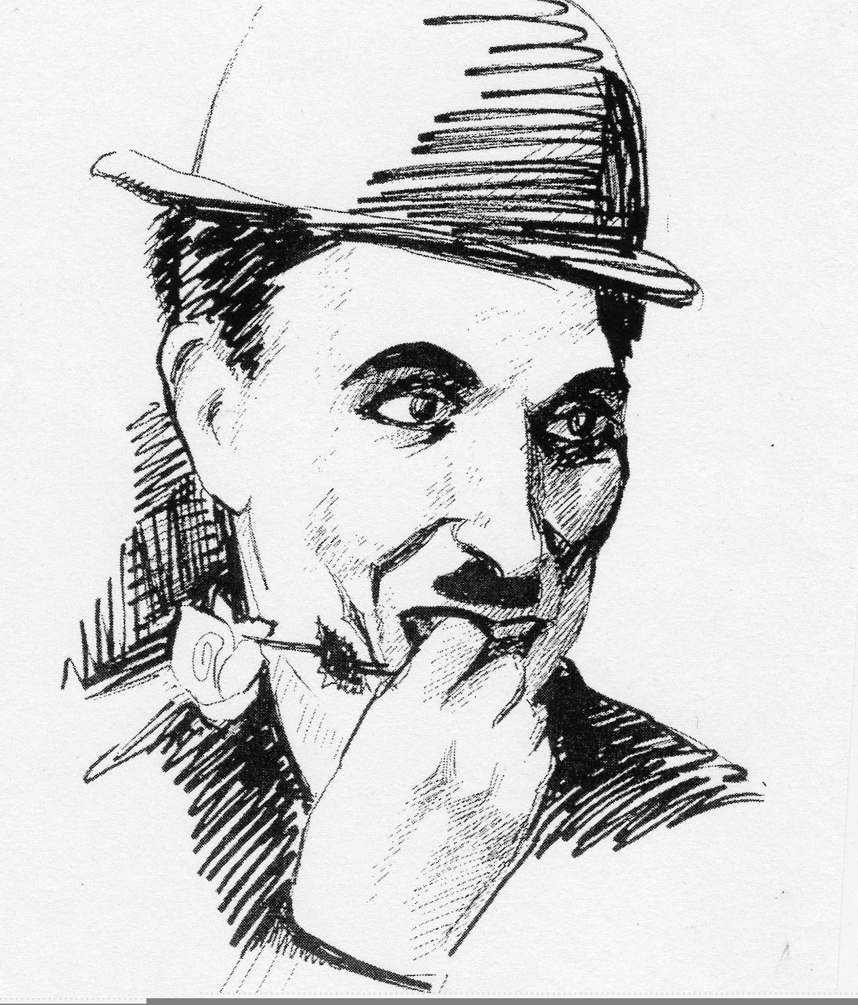

By Arlene Gardipee

